UNA Room Reservation System

Software Architecture Document

# Introduction

This is the Software Architecture Document (SAD) for the University of North Alabama Room Reservation System. The room reservation system is a product of the CIS 445, CIS 466, and CIS 486 classes.

## Purpose

The Software Architecture Document (SAD) represents the software architecture for the Room Reservation System being created by students at the University of North Alabama. The document is intended to provide a high-level outline for the system and the architecture behind it.

## Scope

The scope of the SAD covers the boundaries of the project and the required design to be implemented for successful completion of the project.

## Definitions, Acronyms and Abbreviations

**RUP**: Rational Unified Process

**UML:** Unified Modeling Language

**SAD:** Software Architecture Document

## References

IBM® Rational Unified Process®

# Architectural Representation

Presentation view – The team in CIS 486 will be working on the presentation view which will be how users interact with the system.

Controller view – The team in CIS 466 will be working on the middle tier that connects the backend database to the front end application.

Database view – The team in CIS 445 will be working on the database for the system.

# Architectural Goals and Constraints

As the room scheduling system has the potential to be used by the entire university, it is being built with reuse and expansion capabilities as a priority. At first, the room scheduling system will be limited to the College of Business, with the likelihood of expanding into other colleges over future semesters. The main objective of the system is to allow any faculty or staff who need to schedule a room to do so easily through the system’s web-based interface.

# Use-Case View

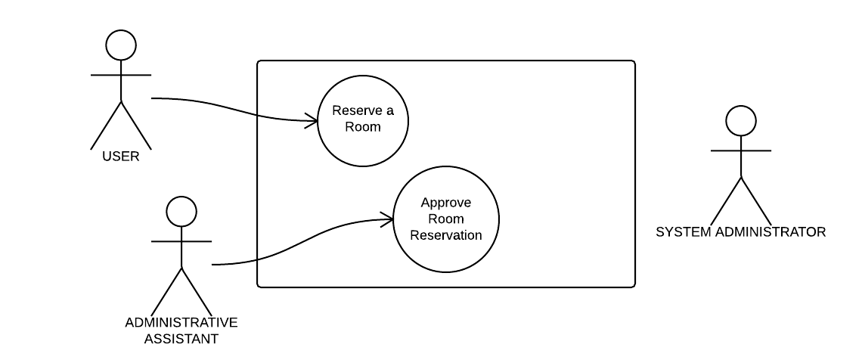

## Use-Case Realizations

Users will be able to reserve a room. Administrative assistant will be able to approve or deny the room reservation. The system administrator will be responsible for the maintenance and upkeep of the system.

# Logical View

## 

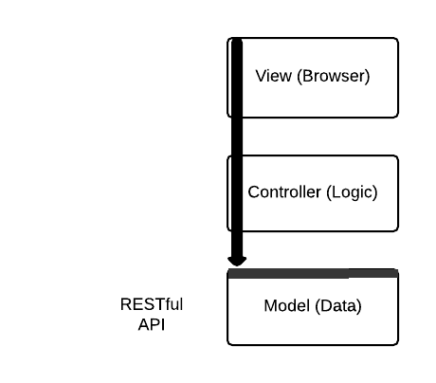

## Overview

The design of the system consists of three main parts: the model, view and controller. The view will be what the user sees when they access the system from the browser. The controller contains the logic for the system. The model contains the data for the system.

# Process View

# 

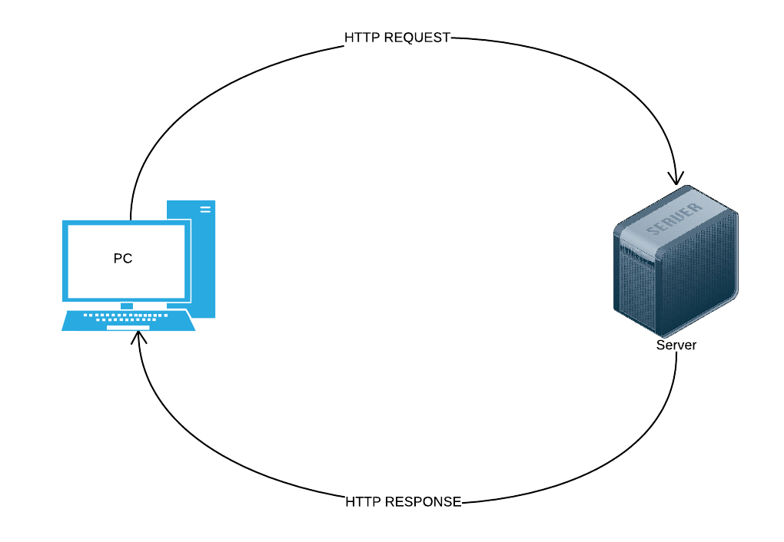

# Deployment View

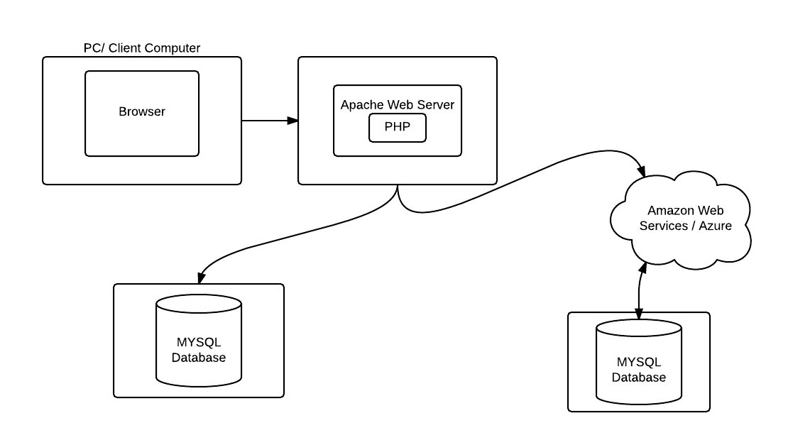

# Implementation View

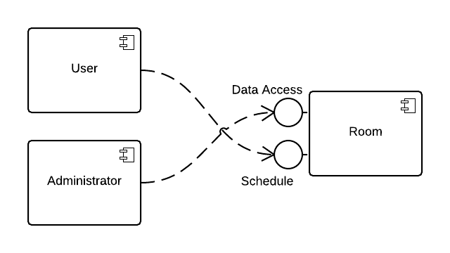

# Size and Performance

As the system will likely only be utilized by only a handful of people at any given time, performance should remain very stable. The server that will be hosting the system will be located within the UNA network, meaning that the system will only be accessible through the on-campus network. The size of the system is relatively small and can be easily contained within a single server.

# Quality

Any user of the system can make a request to reserve a room. Only room reservation requests that are approved will be shown in the system. Quality will also be ensured by only allowing system administrator’s to have access to approve and deny room reservation requests.